INFLUENCE OF CORPORATE GOVERNANCE ON COMPANY VALUE WITH STOCK RETURN AND FINANCIAL PERFORMANCE AS A MEDIATOR VARIABLE

Pornpawee Worasatepongsa¹, Suchart Prakthayanon²
¹Fixed Lecturer of Business Administrations Mahidol University, Kanchanaburi Campus, 199 Moo9, Sai-Yok, Kanchanaburi, Thailand, 71150
²Head of Industrial Management Department, Faculty of Business Administrations, Bangkok Thonburi University, 16/10 Thawi Watthana, Bangkok,Thailand, 10170
Corresponding Author: ¹pornpawee.wor@mahidol.edu , pornpawee.wor@mahidol.ac.th
²suchart.prak@bkkthon.ac.th

Pornpawee Worasatepongsa, Suchart Prakthayanon. Influence Of Corporate Governance On Company Value With Stock Return And Financial Performance As A Mediator Variable—Palarch’s Journal Of Archaeology Of Egypt/Egyptology 17(3), 2504-2525. ISSN 1567-214x

Keywords: Corporate Governance, Stock Return, Financial Performance, Company Value

ABSTRACT
This research was aimed at testing the influence of corporate governance on company value through the variable of stock return and financial performance. Data were collected from 50 stocks of companies registered in the Stock Exchange of Thailand (SET50 Index) in 2019. These stocks have good and secure business bases, high trading liquidity, large market capitalization and regular dividend payouts along with good-excellent governance scores from the Corporate Governance Report 2019 of Thailand.

Based on the findings of this examination, it was concluded that corporate governance has negative direct effects on company value and corporate governance has a negative indirect influence through stock returns. However, company value is directly and positively influenced by financial performance. Oddly, this study did not find a direct or reverse correlation between stock return and financial performance in stocks.

INTRODUCTION
This study was aimed at testing the influence of corporate governance on company value through stock return and financial performance of the business. The business’ goal achievement can be shown by financial numbers resulting from effective management and direction ability of high-ranking executives. Effectiveness was measured from ratios by dividing input and output factors. In the meantime, business financial performance increases will lead to company stock attraction from the viewpoint of investors, causing disclosed financial reports to reflect the company’s past performance while helping investors to make investment decisions based on the aforementioned financial information. In particular, any unedited financial report is of great interest to investors.

Corporate governance is an issue given greater interest by investors worldwide, because corporate governance will push businesses to have transparent management, international standards and become accepted by all shareholders and stakeholders. Corporate governance helps businesses to have corporate performance and appropriate return on investment, leading to increase company value. Similarly, the findings of Chen, Chung, Hsu and Wu (2010) found a direct influence from excellent corporate governance on company value. The aforementioned findings were consistent with the findings of Dash and Raithatha (2019) who found correlations of corporate governance to be able to increase company performance.

Many organizations seeking to increase company value will promote strengths and improve weaknesses to increase performance with financial numbers as indicators for comparing performance with competitors in the same industry. In addition, these financial numbers can be used to analyze the company’s financial trends and financial position in the future. This study will help executives discover company disadvantages and corrective guidelines, thereby enabling investors to create opportunity for long-term profit in the future in low-risk companies and enabling analysis to interpret and analyze financial ratios effectively. Purnomo (2018) stated five types of financial ratios are popularly used in financial data analysis consisting of liquidity ratio, efficiency ratio, leverage ratio, profitability ratio and market value ratio. Brigham, De Castro and Shepherd (2007) studied and found return on equity (ROE) to be most commonly used measurement of company profit. ROE is net profit divided by total shareholder’s equity. Higher ROEs cause higher trends for par value, causing investors to consider investing in stocks with high ROE for possession in order to create wealth. In the meantime, Azis and Hudayah (2018) studied by using fixed-impact economic models and random models to survey correlations between corporate governance and company performance. From data collected for five years retrospectively, the governance variable was found to be related to accounting performance (EVA, ROA and ROE) and MVA in the Stock Exchange of India (NIFTY50) with significance. At the same time, Coleman (2007) studied and found corporate governance measured by CEO duality, board size, frequency of board meetings, size of audit committees, audit committee independence, organizational size, organization age and institutional share holdings were found to have a positive and significant influence on company performance measured by using ROA and Tobin’s Q. Mashayekhi and Bazaz (2008) found corporate governance measured from board size, board independence, CEO duality and institution directors to be negatively related to financial performance measured from Tobin’s Q, ROE, ROA, EPS and annual stock return.

In the past, most investors created wealth by depositing cash with banks, buying gold, land and housing with cash at full value. However, investors currently focus on investing to create wealth with stocks and bonds in securities expected to have good returns, low risk and less investment capital. Therefore, capital markets are a good choice for investments using low amounts of capital. For most people, if capital markets operate with stability and transparency, all parties involved will enjoy prosperity. Thus, corporate governance became a major issue in the business world along with studies from financial scandals worldwide and lack of confidence in Islamic business operations (2019). Similarly, capital markets in Thailand contributed to the country’s effective economy. However, a considerable number of listed companies in the country’s stock exchange manipulated stock prices and exaggerated performance, causing 257 companies to be removed from the Stock Exchange of Thailand from 1975 – present day (Stock Exchange of Thailand, 2020). Therefore, if all companies can follow corporate governance principles, companies will be able to create effective performance and company value in line with investors’ expectations.

Many academics have studied the correlation between corporate governance and company value such as Aggerwal, Schloetzer and Williamson (2019), who found corporate governance to be slightly and positively correlated with company value in the case of companies involved with the government sector. This was consistent with a study conducted by Jauhar (2014) who found corporate governance (the proportion of independent audit committees, the proportion of independent commissioners) to be positively correlated with company value measured with MBR, Tobin’s Q and closing price. In addition, Connelly et al. (2012) found companies with corporate governance (board size, board independence) to have a negative influence on company value measured with Tobin’s Q, ROA, firm size, capital expenditures, financial leverage, corporate index and family ownership. However, Utami, Nuryani and Nugraha (2020) did not find a correlation between corporate governance and company value. Similarly, Wulandari and Widaryanti (2008) did not find any correlation between corporate governance and company value. Ardillah (2018) and Utami, Nuryani and Nugraha (2020) also did not find correlations of coroproate governance measured by ratio of independent directors to company value. Wahab et al. (2007) studied 440 companies listed with the Stock Exchange of Malaysia and found higher corporate governance measured from Corporate Governance Index to have a significant and positive influence on investors’ wealth when measured by market to book of equity (MBVE). Shahwan (2015) studied the correlation between corporate governance and financial performance of 86 non-financial companies in Egypt that were selected using the Corporate Governance Index (CGI) under conditions where the companies were open, transparent companies with independent directors, shareholders, investors and company owners in the structure of high-ranking executives. According to the findings from the aforementioned study, no influence from corporate governance was found on the financial performance of all 86 companies while Schilling (2001) found a positive influence from corporate governance among listed companies in Germany on wealth creation for shareholders measured with dividend yield and earnings per share.

In studying the influence of stock return on company performance, Alotaibi and Azibi (2016) found stock return to have a positive influence on company performance (NPM, Sales Growth, Tobin’s Q, Size, Age, B/M Ratio) while Laurens (2018) studied and found earnings per share (EPS) to be related to stock return. Similarly, Alwathainani (2009) studied and found company financial performance growth to be able to predict future returns. However, Trueman et al. (2003) stated past performance can explain future returns in transparent companies. In a study conducted by Julianto and Syafarudin (2020), a positive correlation was found between stock return and company value. Lehn and Makhija (1996) studied financial performance measured based on EVA, MVA, ROA, ROE and ROS and found financial performance to be positively correlated with stock return. In another study, Sharma (2009) found financial performance measured with ROA, MVE, BE, B/Mratio to have no influence on stock return with significance.

According to the present study, corporate governance was not the only variable with influence on stock return. Many academics studied significant stock returns. Jiao (2010) conducted a study finding increases in stock return to have increased company value when measured from Tobin’s Q and B/M. This was similar to the findings of a study conducted by Johnson et al. (2005) who found stock return to have significant influence on company value. Ardiansari, Nugrahaini and Wiratno Putri (2018) studied and found the financial performance of companies to have influence on company value. Similarly, Thendean and Layadi (2019) found profitability ratios to have a positive influence on company value with significance. This was concurrent with a study conducted by W and E (2019) who found financial performance to have influence on company value. Muamilah, Asdar and Sobarsyah (2019) collected stock data in Indonesia (IDX) from 2013-2017 and found financial performance to have influence on company growth with statistical significance and financial performance had a positive influence on company value with statistical significance. On the contrary, Manaje (2012) found a negative correlation between financial performance and company value.

The Stock Exchange of Thailand supports companies listed with the Stock Exchange to consider and pass evaluation criteria continually. This is noticeable in how 677 registered companies in Thailand had scores in the Corporate Governance Report (CGR) at an average of 82 percent, the highest level from when CGR scores began to be evaluated in 2001. In addition, Thai companies were found to have given importance to sustainable business operations along with aggressively modifying board of director roles and leadership in line with corporate governance principles and shareholders’ expectations (Securities and Exchange Commission, 2017). According to consideration of mean scores by section from survey results in 2019, the sections with mean scores higher than 80 percent were found to be 1) shareholders’ rights, 2) equitable treatment of shareholders, 3) disclosure of information and transparency and 4) consideration of stakeholder roles with mean scores of 94 percent, 92 percent, 86 percent and 81 percent, respectively. However, in the section on board of directors’ responsibilities, companies had a mean score of only 75 points while having better development than every section, which is considered a good trend. According to survey results, 258 listed companies were found to have mean score of 80 percent and up or four stars (38%) and 193 companies or 29 percent of all surveyed companies had a mean score of 90 percent and up or five stars (Research and Development Department, Thai Institute of Directors, 2019). Therefore, studies involving companies in Thailand are of interest to this study. Thus, the research objective was specified to test influence of corporate governance on company value through the variables of stock return and financial performance. The findings can be used as an instrument to analyze investments in the Stock Exchange of Thailand under corporate governance to provide guidelines for building long-term prosperity for investors.

The findings from previous studies conducted by academics can determine variable correlations, meaning corporate governance had a positive influence on three variables consisting of stock return, company financial performance and company value. In addition, stock return influenced company financial performance and company financial performance influenced stock return. Company stock return and financial performance both had a positive influence on company value. Thus, the researcher was able to create the following research conceptual framework and hypothesis:
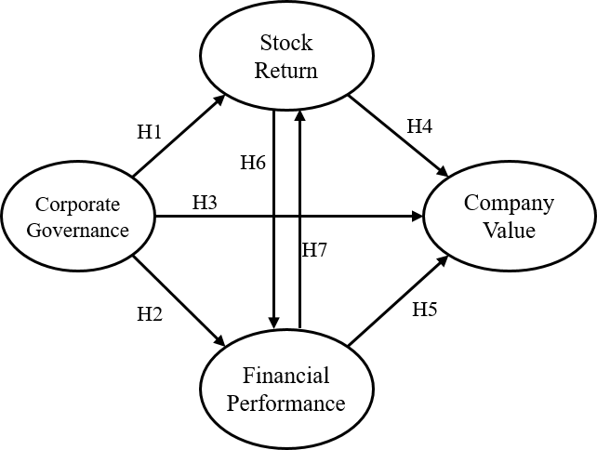

Figure 1 – Conceptual Framework of the Study

The research hypothesis can be determined based on the aforementioned research conceptual framework according to the lines with arrows in the image with the following definitions:

H₁: Corporate Governance Has a Direct and Positive Influence on Stock Return
H₂: Corporate Governance Has a Direct and Positive Influence on Financial Performance
H₃: Corporate Governance Has a Direct and Positive Influence on Business Value
H₄: Stock Return Has a Direct and Positive Influence on Business Value
H₅: Financial Performance Has a Direct and Positive Influence on Business Value
H₆: Stock Return Has a Direct and Positive Influence on Financial Performance
H₇: Financial Performance Has a Direct and Positive Influence on Stock Return

LITERATURE REVIEW
This study was aimed at testing influence between variables under the basic theory for testing influence between variables according to the following information:

Agency Theory

The Agency Theory was presented by Jensen and Meckling (1976) based on the hypothesis that companies are separate from ownership. The organization’s relationship is a contract between more than one person as the owner and others as a representative who acts in the owner’s interests, including granting decision-making authority to proxies with the objective of maximizing company value. From one perspective, Jensen and Meckling (1976) recognized that company owners cannot manage alone, causing company owners to need other persons to help manage on behalf of the company owner. This theory explains the agency relationship as something that occurs between both parties with the party granting power being the principle while the other party with management assignments is called the agent. The Agency Theory is based on the hypothesis of the company as separate from shareholders (owners). The relationship is a contract between one person as the agent who will act for the benefit of the owner including an authorization of the agent for the objective of maximizing company value as long as the executive or agent make investment decisions to generate maximum returns on investment in methods consistent with creating maximum benefit for shareholders. The agency relationship between shareholders and executives is also effective and creates positive effects for performance. However, if the benefits and objectives of shareholders and executives are inconsistent, there will be agency problems Srijanpetch (2008). According to the Agency Theory, if the agent manages work fully without taking benefits belonging to shareholders for personal gain or for the gain of others to create maximum value for the company, including stakeholders. However, management may encounter problems from executives or agents without sufficient knowledge who do not work at full capacity and executives who take the company’s benefits for personal gain or for others. This may cause shareholders or owners to not receive expected benefits. Therefore, the concept of corporate governance has come to play a major role in helping shareholders or company owners be certain of receiving fair stock return and dividends (Shleifer and Vishny, 1997). Thus, corporate governance controls representatives to manage with honesty, thereby leading to improvements in company performance by improving company performance efficiency.

Residual Dividend Theory – This theory requires companies’ net profits to be allocated as shareholders’ equity (accumulated profits) for use as an investment budget before paying out the remaining net profit as dividends (Bender and Ward, 2020). The returns sought by shareholders were dividends and capital gains. Companies in growth show a lesser trend of determining dividend pay outs than companies that have passed the growing period.

Clientele Effect is a trend where a company needs to attract investors by setting a dividend payout policy satisfactory to investors. Investors prefer to invest in companies that pay out more dividends. If investors need regular income, investors will need high dividends. However, investors who do not need income from cash will choose to invest in companies that offer low dividends based on the following principles and agreements of Miller and Modigliani:

3.1 Companies specify dividend payout policies to attract interest from investors who prefer dividend payouts.
3.2 Tax differences between what investors will receive while paying dividends and profit from stock trading will be reasons used by companies as a proposal and attract investors with bias in dividend payout policies.

The Theory of Power – The Theory of Power is a theory in which the manager has the power to decide in the name of the company while shareholder the power to determine the company’s direction by voting (Wantana, 2014) and ownership can reduce agency problems between shareholders and managers. If managers also function as shareholders, managers will have even more power in the company. The most outstanding person can determine company policy such as consideration of dividend pay outs and stock prices (Smith and Watts, 1992).

Signaling Theory – The Signaling Theory proposes that investors should study to determine behaviors signaled by companies or major shareholders to minor shareholders, which may lead to higher or lower stock prices. This theory was presented by Ross (1977) as a method for companies to signal persons who use reports of information related to managers’ actions to show recognition of owners’ needs. These signals may be in the form of specifications that stock returns of the company are better than other companies. Dividend payouts higher than the industrial average cause stock prices to rise. Therefore, the higher the stock price, the higher company value (Husnan, 2012).

Asymmetry Theory – Asymmetry Theory posits that the parties related to companies do not have equal opportunity to receive information and managers usually have better information than outsiders such as investors.

Net Income and Free Cash Flow – This Theory was presented by Jensen and Meckling (1976) who explained that companies with good profits will be viewed as a good investment situation and a goal, specifically from major investors who hope for fixed dividends than income from profit from increased price differences.

The Bird in the Hand Theory – Gordon et al. (2002) and Lintner (1956) stated dividend pay outs increase company value because investors estimate cash flow in the future to be uncertain. Thus, investors want more certain dividends than uncertain profit in the future.

Clientele Effect – This theory states that each shareholder has different needs for the company’s dividend payout policy. For example, shareholders who need high current income want dividend payouts at a high rate. At the same time, the group that does not want a large amount of money at this time wants the company to hold the majority of profits and pay out only a small amount of dividends for investors’ personal tax benefits.

Miller and Modigliani argued about the effects stemming from the needs of investors seeking income from investments and purchasing stocks in companies that pay high dividends while investors who do not want cash income will now invest in companies that pay dividends later. Miller and Modigliani’s argument caused companies to create a fixed dividend payout policy drawn from investors’ needs, causing most investors to prefer the aforementioned dividend payout policy. In addition, tax differences between dividends and profit from investments may lead to trends of each company to create attractions for investors who consider company dividend payout policies or company dividend payouts (Brigham, 1995).

Different views about dividends and profits from investment can be explained through the concept of Gordon, Hrazdil, Shapiro (2012) about the Bird in the Hand Theory. In other words, this group of investors prefers to receive current income in the form of dividends. Therefore, this group of investors wants companies to pay out large amounts of dividends and this group of investors will consider risks and certainty of returns from the understanding that current income in the form of dividends is worth more than profit from investments because this will help to reduce risks and reduce uncertainty. Litzenberg and Ramaswamy researched theories on setting the value of tax trends and found this group of investors will not hope for dividends but will hope for profit from investments with causes from high tax payments when receiving high dividends. Moreover, this group of investors viewed that companies paying low dividends will have high accumulated profits and companies can invest accumulated profit to generate more profit in the future. In conclusion, current stock value of companies will increase in the future, thereby causing investors to have higher profit trends.

RESEARCH METHODOLOGY
This study collected data from 50 stocks of companies listed with the Stock Exchange of Thailand (SET) and in the SET50 index in 2019. These stocks had a good business base, security, consistent growth in performance, high liquidity of purchase-sales, large market capitalization and regular dividend payouts (Stock Exchange of Thailand, 2020).

Exogenous variables are variables with positive or negative effects on endogenous variables (Ferdinan, 2006). This study had corporate governance (CG) as an exogenous variable with the following observable variables: 1) independent director ratio (CG1), institute shareholding ratio (CG2), executive shareholding ratio (CG3), Outsider Shareholding Ratio (CG4) and the researcher added the variable of the Corporate Governance Report 2019 (CG5) (Stock Exchange of Thailand, 2020).

Variables that were both exogenous and endogenous were stock return (ST) and financial performance (FP) variables. Stock returns had two variables used to measure consisting of abnormal return (ARt) dividend yield (DY) and Earnings Per Share (EPS). ARt was calculated from real return (Rt) deducted by expected return ($\hat{R}$t), which was calculated from the Capital Asset Pricing Model (CAPM), meaning:

$\hat{R}$t = + ($\hat{β}$x$RM$t) ................................................................1)

Where: is the Y axis intercept point.
$\hat{β}$ is the slop of the graph from a linear equation that shows the relationship between SET index returns and stock return during normal trading hours. (Capital Market Research Institute, 2013)

Dividend yield (DY) is a financial ratio comparing dividend per share and par value on the date of calculating the following equation:

Earnings Per Share = (Net profit / (Total shares)) x100 ………..(2)

Earnings Per Share (EPS) This measures the extent of profit available to the equity shareholders.

Dividend Yield = (Dividend / (Price/share)) x100 ……….......... (3)

Financial performance (FP) consisted of the following three variables: free cash flow (FCF), return on assets (ROA) and return on equity. Financial performance was calculated from operating cash flow, deductions for good investments, building, equipment and copyright fees (Capital Expenditure: CAPEX).

FCF = Operating Cash Flow – Capital Expenditures ...................(4)

Return on assets (ROA) is a ratio that will help measure profitability and determine percentage of profit from total assets calculated from dividing net profit with total assets according to the following formula:

ROA = (Net Profit / Total Assets) x 100 ..........................................(5)

Return on equity was calculated by dividing net profit with total equity according to the following formula:

ROA = (Net Profit / Total Equity) x 100 ..........................................(6)

In this study, the endogenous variable of company value had two indicators consisting of market to book value (MBV) and price earnings ratio (P/E ratio) in the following formula:

MBV = (Market Price/share) / (Book Value/share) ........................(7)

P/E ratio = (Market Price / share) / (Earning / share) .....................(8)

From determining the correlations between the exogenous and endogenous variables, the variables used in measurements and data analysis were identified by using the Structure Equation of Model (SEM) shown in the following image:

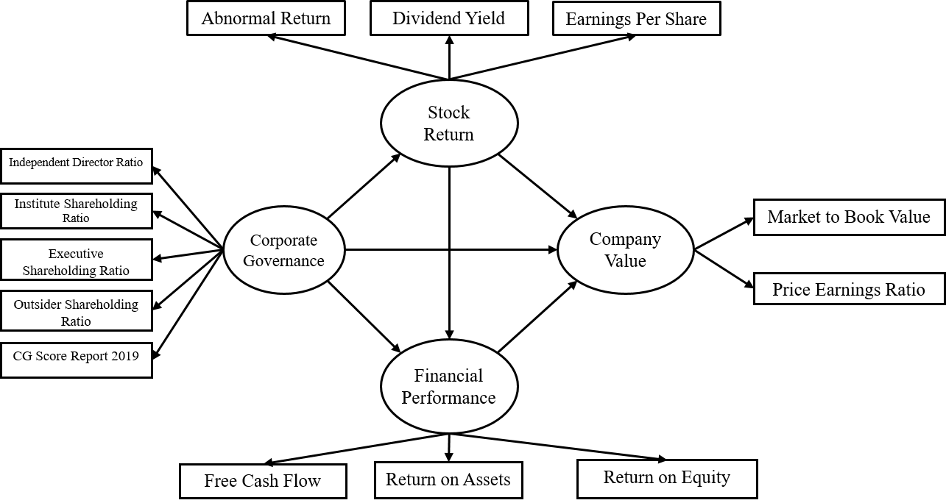

Figure 2: Structural Equation of Model: Model A

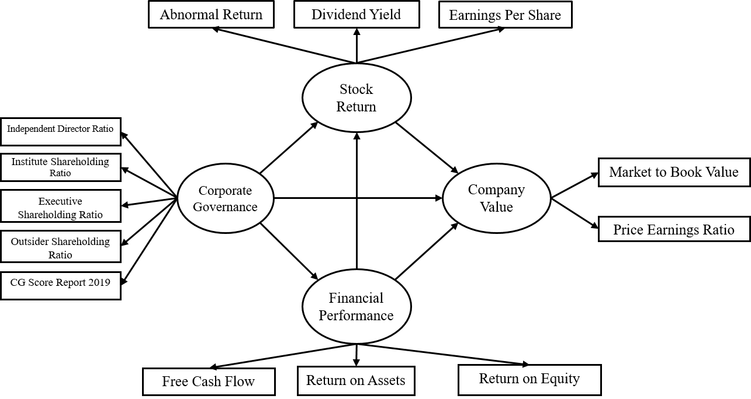

Figure 3: Structural Equation of Model: Model B

Findings and Discussion of the Findings

In the aforementioned test of influence from corporate governance on company value through the mediator variables (stock return and financial performance) the researcher conducted preliminary reliability and validity testing in line with standard criteria, meaning Cronbach’s Alpha Coefficient at 0.6 and up (Hair et al., 2013), composite reliability at 0.6 and up (Chin, 1998; Hock et al., 2010) and average variance extracted (AVE) at 0.5 and up (Chin, 1998; Hock and Ringle; 2006). According to reliability and validity test results, the variable with Cronbach’s Alpha Coefficient at 0.6 and up in Model A and Model B was stock return. In addition, the variables with composite reliability at 0.6 and up in Model A and Model B were company value, corporate governance and financial performance while Model B had company value, financial performance and stock return which met criteria. Average variance extracted (AVE) scores from 0.5 and up in Model A and Model B was found in company value, financial performance and stock return. However, if suitability of the structural equation in Figure 2 were considered, the Coefficient of Determination (R²) for latent endogenous variables was shown in Table 1.

Table 1 – Coefficient of Determination (R²), Model A

Predictive Variables | Endogenous Variables
 | Stock Return | Financial Performance | Company value
Corporate Governance | 0.463 | 0.061 | 0.654
Stock Return
Financial Performance

According to Table 1, R² of stock return was 0.320 with corporate governance as a predictive variable, meaning corporate governance was able to explain stock return fluctuations at 32 percent. R² of financial performance was 0.561 with corporate governance and stock return as predictive variables, meaning corporate governance and stock return were able to co-predict fluctuations of financial performance at 56.1 percent. R² of company value was 0.665 with corporate governance, stock return and financial performance as predictive variables, meaning corporate governance, stock return and financial performance were able to co-predict fluctuations of company value at 66.5 percent.

Table 2 – Coefficient of Determination (R²), Model B

Predictive Variables | Ingenuous Variables
 | Financial Performance | Stock Return | Company Value
Corporate Governance | 0.056 | 0.465 | 0.653
Financial Performance
Stock Return

According to Table 2, R² of financial performance was 0.056 with corporate governance as a predictive variable, meaning corporate governance was able to explain stock return fluctuations at 5.6 percent. R² of stock returns was 0.465 with corporate governance and financial performance as predictive variables, meaning corporate governance and stock return were able to co-predict fluctuations in financial performance at 46.5 percent. R² of company value was 0.653 with corporate governance, stock return and financial performance as predictive variables, meaning corporate governance, stock return and financial performance were able to co-predict fluctuations of company value at 65.3 percent.

The results from this hypothesis test used t-test statistics to test influence between variables with t valued at 1.96 or p-value less than 0.05 to be considered as having statistical significance α=0.05 as a two-tailed test shown in Table 3.

Table 3 – Hypothesis test result of Model A and Model B

Hypothesis  Model A |  | Original Sample(O) | Sample Mean(M) | Standard deviation(STDEV) | T statistics (abs(O/STDEV)) | P-Value
H1 | CGST | 0.680 | 0.689 | 0.059 | 11.617 | 0.000
H2 | CGFP | -0.162 | -0.185 | 0.245 | 0.664 | 0.507
H3 | CGCV | -0.263 | -0.266 | 0.109 | 2.404 | 0.016
H4 | STCV | -0.336 | -0.336 | 0.094 | 3.578 | 0.000
H5 | FPCV | 0.474 | 0.462 | 0.142 | 3.336 | 0.001
H6 | STFP | -0.106 | -0.102 | 0.190 | 0.558 | 0.577
Hypothesis  Model B |  | Original Sample(O) | Sample Mean(M) | Standard deviation(STDEV) | T statistics (abs(O/STDEV)) | P-Value
H1 | CGST | 0.666 | 0.682 | 0.066 | 10.115 | 0.000
H2 | CGFP | -0.237 | -0.257 | 0.172 | 1.376 | 0.169
H3 | CGCV | -0.263 | -0.267 | 0.115 | 2.285 | 0.023
H4 | STCV | -0.334 | -0.332 | 0.091 | 3.661 | 0.000
H5 | FPCV | 0.474 | 0.465 | 0.139 | 3.422 | 0.001
H7 | FPST | -0.059 | -0.051 | 0.111 | 0.529 | 0.597

According to Table 3 showing test results of influence of corporate governance on company value through the variables of stock return and financial performance, Model A and Model B were found to have provided consisted test results. In other words, company value was negatively influenced by corporate governance and stock return and was positively influenced by financial performance while corporate governance positively influenced stock return as shown in Figures 4-5.
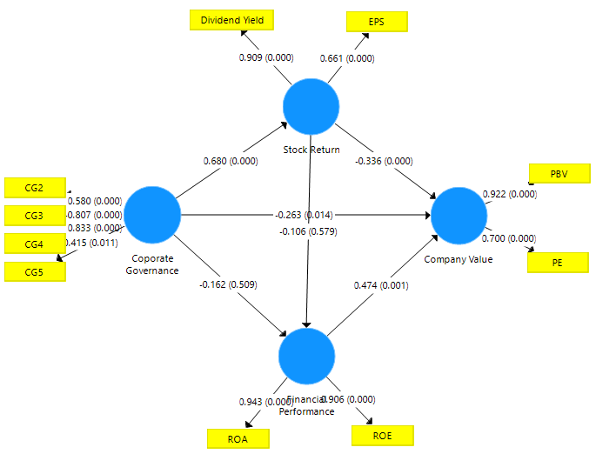

Figure 4 – Testing of Corporate Governance Influence on Company Value Model A

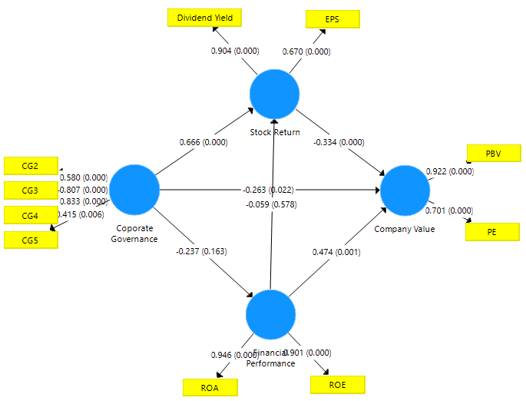

Figure 5 – Testing of Corporate Governance Influence on Company Value Model B

Test results of the Structure Equation Model in Figures 4-5 caused the researcher to re-modify the Structure Equation Model into Model C by removing insignificant correlation lines to test new influence with results shown in Table 6.

Table 4 – Hypothesis test for model C
Hypothesis  Model C |  | Original Sample(O) | Sample Mean(M) | Standard deviation(STDEV) | T statistics (abs(O/STDEV) | P-Value
H1 | CGST | 0.683 | 0.693 | 0.051 | 13.285 | 0.000
H3 | CGCV | -0.269 | -0.268 | 0.114 | 2.361 | 0.018
H4 | STCV | -0.331 | -0.328 | 0.097 | 3.396 | 0.001
H5 | FPCV | 0.478 | 0.473 | 0.144 | 3.327 | 0.001

According to Table 4 on the results from testing influence of corporate governance on company value through the variables of stock return and financial performance in Model C, company value was found to be negatively influenced by corporate governance and stock return. Thus, Hypothesis H3 and Hypothesis H4 were denied. In addition, company value was positively influenced by financial performance, causing Hypothesis H5 to be accepted while corporate governance had a positive influence on stock return and Hypothesis H1 was accepted with statistical significance at 0.05 as shown in Figure 6-7. These variables were able to directly and indirectly influence one another. To clearly summarize influence of cause variables on dependent variables, the researcher presented Table 5.

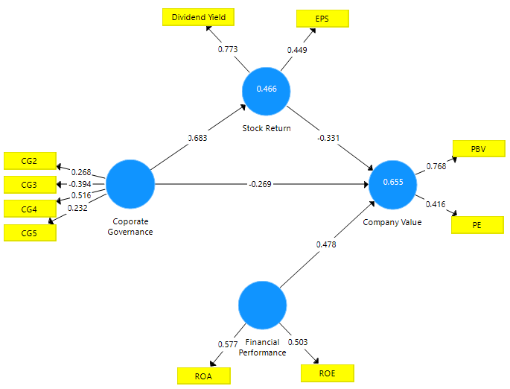

Figure 6 – Structure Equation Model, 2nd Revision, Model C

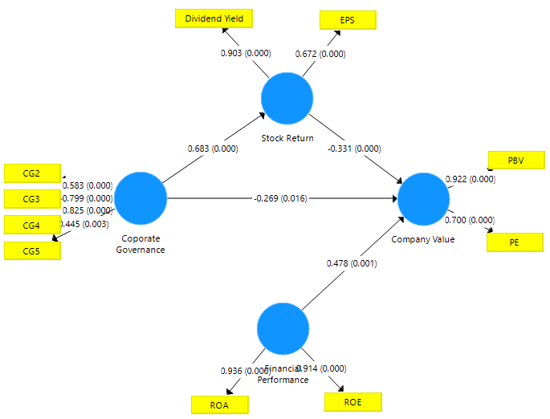

Figure 7 – Structure Equation Model, 2nd Revision, Model C, with p-value

Reliability and validity values had criteria consisting of Cronbach’s Alpha Coefficient at 0.6 and up, composite reliability at 0.6 and up and average variance extracted (AVE) at 0.5 and up. According to test results of Model C, only Cronbach’s Alpha Coefficient at -0.454 was found in the governance variable inconsistent with the aforementioned criteria. The analysis results from Figure 6 had stock return R² equal to 0.466 with governance as a predictive variable, meaning corporate governance was able to explain stock return fluctuation variables at 46.6 percent. R² of company value was at 0.655 with corporate governance, stock return and financial performance as predictive variables. In other words, corporate governance, stock return and financial performance were able to jointly explain fluctuations of company value at 65.5 percent.

Table 5 – Direct Effect, Indirect Effect and Total Effect

Dependent Variables | R²  (Percent) | Influence | Causal Variables
 |  |  | CG | ST | FP
Stock Return (ST) | 46.6 | DE  IE  TE | 0.683***  -  0.683*** | -  -  - | -  -  -
Company Value (CV) | 65.5 | DE  IE  TE | -0.269*  -0.226**  -0.495*** | -0.331***  -  -0.331*** | 0.478***  -  0.478***
*P-value< 0.05, ** P-value < 0.01, *** P-value < 0.001.

According to the table 5, variables directly influenced company value (CV) consisting of corporate governance (CG), The CG had negative direct effect on CV with statistical significance at 0.05 and a direct effect score was -0.269. Moreover, CG was negative indirect effect through the mediator variable of stock return (ST) with statistical significance at 0.001 and an indirect effect score was -0.226, causing CV to have total effect from CG at -0.495 with statistical significance at 0.01.

In addition, this study found increases in CV to be a result of positive direct effect from financial performance (FP) and a direct effect score was 0.478 with statistical significance at 0.001. While CV was negative direct effected from ST with statistical significance at 0.001 and direct effect score was 0.331. However, ST was positive direct effected by corporate governance with statistical significance at 0.001 with an direct effect score was 0.683.

CONCLUSION AND DISCUSSION OF THE FINDINGS
This study was aimed at testing the influence of corporate governance(CG) on company value (CV) through the variables of stock returns(ST) and financial performance(FP) of companies listed in the Stock Exchange of Thailand in the SET50 Index in 2019. Corporate governance (CG) has negative direct effect and negative indirect effect on company value(CV) with statistical significance, that was corporate governance (CG) is linked to the company value (CV), even if the increase in the company value (CV) is not caused by corporate governance(CG). This was different from the findings of Aggarwal, Shloetzer and Williamson (2019) who found positive influence of corporate governance on company value. Stocks in Thailand’s SET50 index were stocks with a good business base, security, continual growth in performance, high trading liquidity, large market capitalization and regular dividend payouts. Therefore, increases in market value were not a result from corporate governance only, thereby causing many academics to find no correlations between corporate governance and company value. This was similar to Utami, Nuryani and Nugraha (2020); Wulandari and Widaryanti (2008). Test results found corporate governance to have positive direct effect on stock return because corporate governance requires disclosure of information, transparency in management and executives from associated persons. This created fairness for investors and fair policies for investors such as dividend payout policies and disclosure of real net earnings per share to create prosperity for shareholders. This finding is consistent with the Signaling Theory studied by Ross (1977), meaning the theory should be studied by investors for behaviors used by companies or major shareholders to signal minor shareholders, which may lead to increases or reductions of stock prices. Similarly, Wahab et al. (2007), Schilling (2001); Shleifer and Vishny (1997) found a positive influence on building wealth for shareholders measured by dividend yields and earnings per share. However, the findings from this study discovered no correlation between corporate governance and financial returns of companies registered in the Stock Exchange of Thailand in the SET50 index. This finding is consistent with a study conducted by Shahwan (2015) who found corporate governance using CGI criteria to have no influence on financial performance of 86 companies.

Stock return(ST) was positively influenced by corporate governance. However, the findings revealed stock return to have a negative direct effect on company value measured by market price per accounting value per share and market price per net profit per share, meaning stock return fluctuate with company value because investors purchase stocks with high announced dividend payouts based on Tobin’s Portfolio Adjustment Theory (1958). Preferred assets were considered from expected returns and potential risks from investment, meaning stock prices reflected investor expectations. Asset prices changed in a higher direction before announcement of dividend payouts and before announcement of earnings per share payments. However, when dividend payouts and earnings per share have been announced, stock prices will adjust lower. This was different from a study conducted by Julianto and Syafarudin (2020) who found a positive correlation between stock return and company value.

Financial performance(FP) had a positive direct effect on company value because investors’ returns from investment in stocks consisted of 1) dividends and 2) profit gain of stock prices. Investors opting to invest in the long term prefer to invest in stocks with good bases for a long time with expectations for dividends and profits gains of stock prices. However, short-term investors seeking to invest only to receive benefits from profit gains of stock prices. When businesses announce positive performance, stock prices will rise, thereby adding to company value. This was consistent with the findings of a study conducted by Thendean and Layadi (2019); W and E (2019); Muamilah, Asdar and Sobarsyah (2019); Ardiansari, Nugrahaini and Wiratno Putri (2018) who found profitability ratios to have a positive influence on company value with significance.

However, the researcher found no statistically significant correlations between financial performance(FP) and stock return(ST). Similarly, Sharma’s study (2009) found financial performance(FP) measured by ROA, MVE, BE, B/M ratio to have no influence on stock return(ST) with significance.

RECOMMENDATIONS FOR RESEARCH
1. Increases in company value measured with PE and PBV among companies listed in the Stock Exchange of Thailand in the SET50 index in 2019 did not come from corporate governance. Therefore, although companies have good-excellent corporate governance based on Corporate Governance Report 2019 of Thailand, this did not cause stock prices to increase correspondingly. Investors should consider other basic factors such as profitability, which reflected stock prices with significance.
2. Corporate governance positive direct effect on stock return. Therefore, if investors focus on long-term investment and expectation returns in dividends, investors must choose to invest in stocks with good corporate governance.
3. In the SET50 group, dividend size did not reflect financial performance and financial performance was not related to stock return. Investors should look at investment goals such as profit gains from stock prices or returns form dividends. If investors seek only profit gains from stock prices, investors can look at stocks. Good financial performance influences increases in company value.

REFERENCE
Aggarwal, R., Schloetzer, J. D., & Williamson, R. (2019). Do corporate governance mandates impact long-term firm value and governance culture? Journal of Corporate Finance, 59, 202–217. doi:10.1016/j.jcorpfin.2016.06.007
Alotaibi, E., & Azibi, J. (2016). Income Smoothing and Abnormal Stock Return in the Companies Listed on the Saudi Stock Exchange. SSRN Electronic Journal. doi:10.2139/ssrn.2792373
Ardiansari, A., Nugrahaini, M., & Wiratno Putri, V. (2018). Intellectual Capital Influence on Financial Performance and Company Value. KnE Social Sciences, 3(10), 1242. doi:10.18502/kss.v3i10.3205Thendean, M., & Layadi, A. M. (2019). Analysis of Factors Affecting the Quality of Company Profit and Company Value. SSRN Electronic Journal. doi:10.2139/ssrn.3314493
Ardillah, K. (2018). Effect of Intellectual Capital, Corporate Sustainability Disclosure, and Corporate Governance to The Value of The Company: Empirical Study on Registered SOE in Indonesia Stock Exchange. Jurnal Ilmu Manajemen & Ekonomika, 10(2), 60. doi:10.35384/jime.v10i2.75
Azis, M., & Hudayah, S. (2018). The Impact of Mutual Fund Performance Management on Good Corporate Governance Banking. SSRN Electronic Journal. doi:10.2139/ssrn.3127663
Bender, R. and Ward, K. (2002). Corporate Financial Strategy. 5nd ed., Butterworth-heinemann, An imprint of Elsevier Science, Linacre House, Jordan Hill, Oxford Wildwood Avenue, Woburn, MA.
Brigham, E. F. (1995). Fundamentals of Financial Management. 7th ed.,The Dryden Press, Orlando.
Brigham, K.H., De Castro, J.O. and Shepherd, D.A. (2007). A person–organization fit model of owner–managers’ cognitive style and organizational demands. Entrepreneurship theory and Practice,Vol. 31 No. 1, pp. 29-51.
Bunea, O.-I., Corbos, R.-A., & Popescu, R.-I. (2019). Influence of some financial indicators on return on equity ratio in the Romanian energy sector - A competitive approach using a DuPont-based analysis. Energy, 189, 116251. doi:10.1016/j.energy.2019.116251
Capital Market Research Institute. (2013). The Stock Exchange of Thailand. [Online] Retrieve https://www.set.or.th/th/setresearch/grant/files/2556_1st_master_w.pdf
Chen, W.-P., Chung, H., Hsu, T.-L., & Wu, S. (2010). External Financing Needs, Corporate Governance, and Firm Value. Corporate Governance: An International Review, 18(3), 234–249. doi:10.1111/j.1467-8683.2010.00801.x
Chin, W.W. (1998). The partial least squares approach for structural equation modeling. Modern Methods for Business Research, Lawrence, London, pp.295-336.
Dash, S. R., & Raithatha, M. (2019). Corporate governance and firm performance relationship: Implications for risk‐adjusted return behavior. Managerial and Decision Economics, 40(8), 923–940. doi:10.1002/mde.3080
Eristy Minda Utami, Fani Nuryani, Deden Novan Setiawan Nugraha. (2020).The Effects of Capital Structure and Good Corporate Governance on Company Value. International Journal of Psychosocial Rehabilitation, Volume 24 - Issue 2. DOI: 10.37200/IJPR/V24I2/PR200601
Ferdinan, A. (2006). Metode Penelitian Manajemen, Pedoman Penelitian Untuk Penulisan Skripsi. Tesis, Dan Desert a siIlmu Manajemen, Badan Penerbit Universitas Diponerogo, Semarang.
Gordon, I.M., Hrazdil, K. and Shapiro, D. (2012). Corporate governance in publicity traded small firms: a study of Canadian venture exchange companies. Business Horizons, Vol. 55 No. 6, pp. 583-591, availableat:www.elsevier.com/locate/bushor
Gordon, I.M., Hrazdil, K. and Shapiro, D. (2012). Corporate governance in publicity traded small firms: a study of Canadian venture exchange companies. Business Horizons, Vol. 55 No. 6, pp. 583-591, available at: www.elsevier.com/locate/bushor
Hair, J.F., Ringle, C.M. and Sarstedt, M. (2013). Editorial-partial least squares structural equation modeling: rigorous applications, better results and higher acceptance. Long Range Planning, Vol.46Nos1/2,pp.1-12
Hock, M. and Ringle, C.M. (2006). Strategic Networks in the Software Industry: An Empirical Analysis of the Value Continuum. IFSAM villth world congress, Berlin, available at: www.iblunihh.de/ IFSAm06.pdf
Hock, C., Ringle, C.M. and Sarstedt, M. (2010). Management of multi-purpose stadiums: importance and performance measurement of service interfaces. International Journal of Services TechnologyandManagement,Vol.14Nos2/3,pp.188-207
Husnan, S. (2012). Manajemen Keuangan Teori Dan Penerapan (Keputusan Jangka Panjang). 4th ed., BPFE, Yogyakarta.
Islam, M. (2019). Branding Good Corporate Governance: A Pathway to Strengthen Investors’ Perception and Brand Equity. SSRN Electronic Journal. doi:10.2139/ssrn.3413437
Jacob, S. (2019). Do Corporate Governance Impact Firm Value? An Indian Perspective (November 22, 2019). Available at SSRN: https://ssrn.com/abstract=3491551 or http://dx.doi.org/10.2139/ssrn.3491551
Julianto, A. R., & Syafarudin, A. (2020). Stock Return Analysis and Implications in Company Value (Plastic and Packaging Companies Listed in IDX). International Journal of Engineering Technologies and Management Research, 6(7), 101–118. doi:10.29121/ijetmr.v6.i7.2019.420
Kurniati, S. (2019). Stock returns and financial performance as mediation variables in the influence of good corporate governance on corporate value. CORPORATE GOVERNANCE, 19(6), 1289-1309. doi:10.1108/CG-10-2018-0308
Jensen, M.C. and Meckling, W.H. (1976). Theory of the firm: managerial behavior, agency osts and ownershipstructure. Journal of Financial Economics, Vol.3 No.4, pp.305-360.
Laurens, S. (2018). Influence Analysis of DPS, EPS, and PBV toward Stock Price and Return. The Winners, 19(1), 21. doi:10.21512/tw.v19i1.4496
Lintner, J. (1956). Distribution of incomes of corporation among dividends, retained earnings, and taxes. The America Review, Vol.46No.2,pp.97-113.
Muamilah, H., Asdar, M., & Sobarsyah, M. (2019). Influence of Financial Performance and Capital Structure on Company Growth and Company Value of Advertising, Printing and Media Companies in Indonesian Stock Exchange. Scientific Research Journal, VII(I). doi:10.31364/scirj/v7.i1.2019.p0119600
Purnomo, A. (2018). Influence of The Ratio of Profit Margin, Financial Leverage Ratio, Current Ratio, Quick Ratio Against the Conditions and Financial Distress. Indonesian Journal of Business, Accounting and Management, 1(1). doi:10.36406/ijbam.v1i1.218
Ross, S. (1977). The determinant of financial structure: the incentive signaling approach. The Bell JournalofEconomics,Vol.8No.1,pp.23-40.
Schilling, F. (2001). Corporate Governance in Germany: the move to shareholder value. Corporate Governance, 9(3), 148–151. doi:10.1111/1467-8683.00242
Securities and Exchange Commission. (Nov 2019). The Principle of Corporate Governance. [Online]. Retrieved from https://www.sec.or.th/cgthailand/th/pages/
cgcode/ cgcodeindex.aspx
Shahwan, T. M. (2015). The effects of corporate governance on financial performance and financial distress: evidence from Egypt. Corporate Governance: The International Journal of Business in Society, 15(5), 641–662. doi:10.1108/cg-11-2014-0140
Shleifer, V. and Vishny, R.W. (1997). A survey of corporate governance. The Journal of Finance, Vol. 52 No.2,pp.737-783.
Smith, C.W. and Watts, R.L. (1992). The investment opportunity set and corporate financing, dividend and compensation policies. Journal of Financial Economics, Vol.32No.3, pp.263-292.
Srijunpetch, S. (2008). Governance Theory. Journal of Business Administration. Faculty of Commerce and Accountancy, Thammasat University.
Thai Institute of Directors Association. (Dec 2019). Corporate Governance Report of Thai Listed Companies 2019. [Online]. Retrieved from www.thai-iod.com
The Stock Exchange of Thailand. (2020). Blue Chip Stocks. Invest now. Saving tens of thousands to create millions of dreams. [online]: retrieve from https://www.set.or.th/th/investnow/pdf/blue_chip_stock.pdf
Tobin, J. (1958). Liquidity Preference as Behavior Towards Risk. The Review of Economics Studies: 65-68.
Utami, E. M., Nuryani, F., & Nugraha, D. N. S. (2020). The Effects of Capital Structure and Good Corporate Governance on Company Value. International Journal of Psychosocial Rehabilitation, 24(02), 3002–3011. doi:10.37200/ijpr/v24i2/pr200601
Wanthana, S. (2014). Power Theory. 1st edition., Bangkok: Political Science Association. Kasetsart University.
W. M., & . E. M. (2019). Intellectual Capital, Competitive Advantage, Financial Performance and Company Value Among Banking Industries in Indonesia. Advances in Social Sciences Research Journal. doi:10.14738/assrj.64.6419

